The stack and the heap

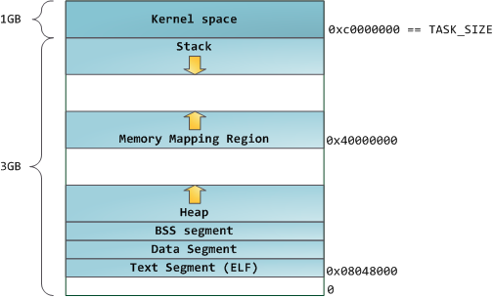

std::vector capacity and stack behavior
Unlike a built-in array or a std::array, which only remembers its size, std::vector contains two separate attributes: size and capacity. In the context of a std::vector, size is how many elements are being used in the array, whereas capacity is how many elements were allocated.
#include <vector>
#include <iostream>

int main()
{
std::vector<int> array { 0, 1, 2 };
array.resize(5); // set size to 5

std::cout << "The size is: " << array.size() << '\n';
std::cout << "The capacity is: " << array.capacity() << '\n';
for (auto const &element: array)
std::cout << element << ' ';

}

If the requested size is bigger than the current capacity, the capacity is usually doubled until it's large enough. This doubling of the size is what keeps the amortized cost of growing at O(1).

Array subscripts and at() are based on size, not capacity
- push_back() pushes an element on the array(vector).
- back() returns the value of the top element on the array(vector).
- pop_back() pops an element off the array(vector).

